**Lesson 5 – Question tags**

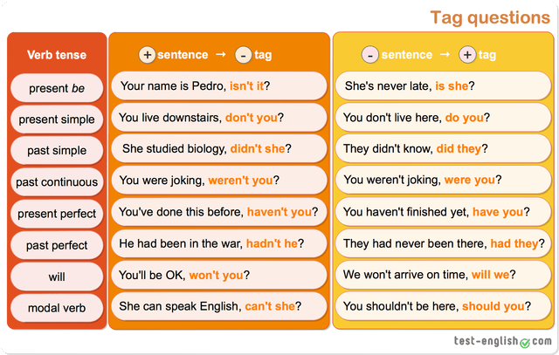

|  |
| --- |
| 1. A tag question is a short question (e.g. **aren’t you?** / **does he?**) that follows a statement.  **Example:** You are a student**, aren’t you?**  He doesn’t like meat**, does he?** |
| 2. Normally we use a positive question tag with a negative sentence. |
| negative sentence **+** positive tag  Tom **won’t** be late**,** **will he?**  They **don’t** like us**,** **do they?**  That **isn’t** Vuthy over there**, is it?** |
| 3. And normally we use a negative question tag with a positive sentence. |
| positive sentence **+** negative tag  There **are** a lot of fruit**,** **aren’t there?**  Da **should** pass his exam**, shouldn’t he?**  They **were** very angry**, weren’t they?** |

**Exercise Practice**

**Instruction 1:** *Match each sentence with its correct question tag.*

|  |  |  |
| --- | --- | --- |
| **Questions** | **Question tags** | **Answer** |
| 1. You are mad about playing chess, … | a. …isn’t it? | 1 => L |
| 2. He isn’t working now, … | b. …had he? | 2 => K |
| 3. They won’t visit New York, … | c. …does it? | 3 => F |
| 4. He hasn’t done his job, … | d. …aren’t they? | 4 => I |
| 5. She found a necklace, … | e. …don’t they | 5 => G |
| 6. She isn’t an honest girl, … | f. …won’t they? | 6 => H |
| 7. They do an excellent job, … | g. …is she? | 7 => E |
| 8. It doesn’t matter, … | h. …didn’t she? | 8 => C |
| 9. They’ll fail, … | i. …has he? | 9 => J |
| 10. They are coming, … | j. …will they? | 10 =>D |
| 11. He hadn’t read the book before, … | k. …is he? | 11 =>B |
| 12. This is amazing, … | l. …aren’t you? | 12 =>A |

*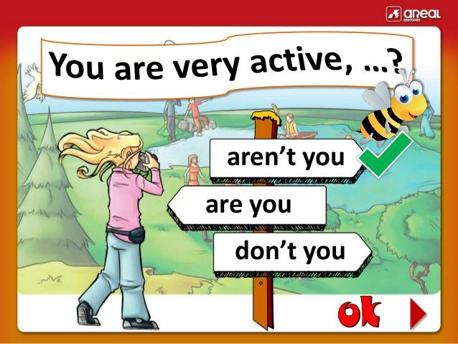***Instruction 2:** Fill in the gap with the correct question tags*.*

|  |  |
| --- | --- |
| 1 | You didn’t visit the museum, __________ |
| 2 | He’s happy to make the trip, __________ |
| 3 | They’ll meet at the airport on Sunday, _________ |
| 4 | She’s single, __________ |
| 5 | You wrote that poem, _________ |
| 6 | You love singing, ___________ |
| 7 | She doesn’t speak English well, _________ |
| 8 | He hadn’t lived there before, _________ |
| 9 | They have done a good job, __________ |
| 10 | There were two car accidents yesterday, ___________ |

**Instruction 3: Find the correct beginning of the sentences.**

1. ________________, can’t he?
   1. He can write b. He can’t sing c. He can’t read.
2. ________________, haven’t we?
   1. They haven’t seen this film b. We’ve seen this film c. We haven’t seen this film.
3. ________________, doesn’t she?
   1. Lavy plays volleyball b. Sophak doesn’t play volleyball c. Rady plays volleyball
4. ________________, wasn’t he?
   1. Kagawa was English b. Mark Twain wasn’t English c. Shakespeare was English
5. ________________, isn’t it?
   1. It’s not your dog b. It’s very hot in the Sahara c. This isn’t Joe
6. ________________, could she?
   1. Sokhour couldn’t sing well b. Vandy could sing well c. Tanghout couldn’t sing well
7. ________________, don’t they?
   1. We often talk to our neighbors
   2. They don’t often talk to their neighbors
   3. They often talk to their neighbors
8. ________________, aren’t they?
   1. Sok and Sao are from Cambodia
   2. Sok and Sao are not from Singapore
   3. Sok is from Malaysia
9. ________________, isn’t there?
   1. It’s raining now b. There’s only one cloud in the sky c. They’re from Japan
10. ________________, aren’t I?
    1. I’m your English teacher b. He’s your English teacher c. You are my English teacher